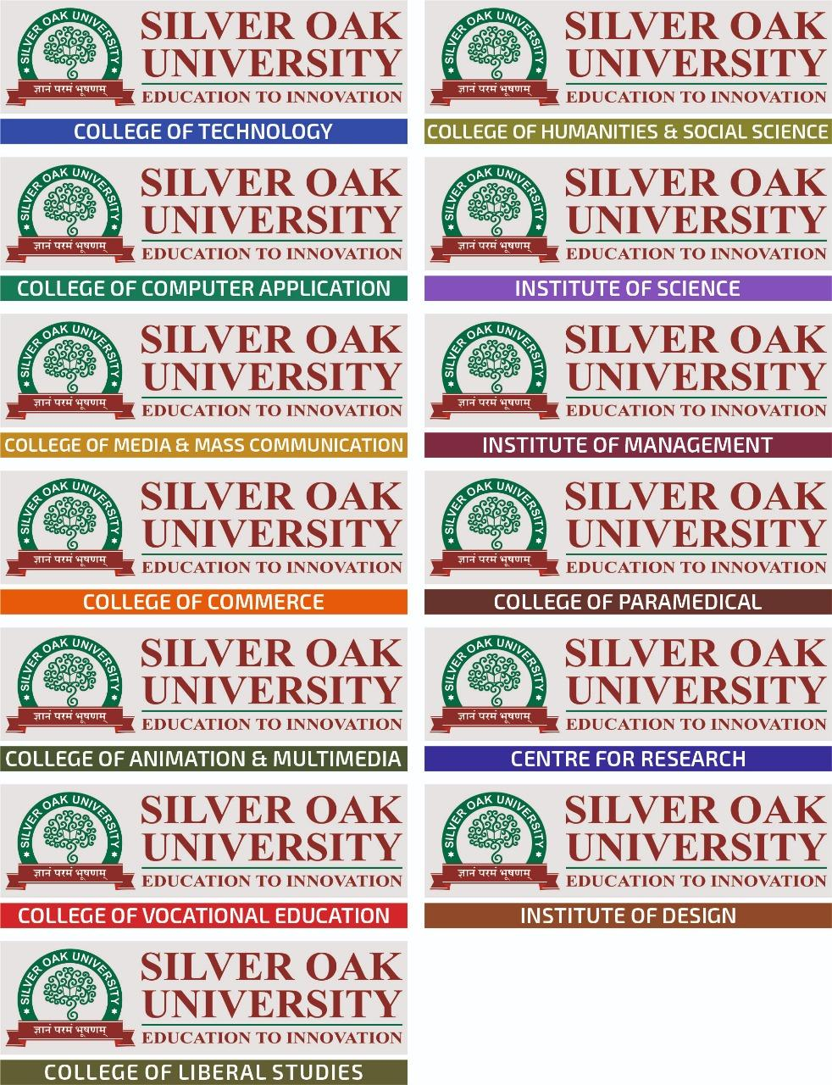

**“TITLE”**

**A DISSERTATION PROJECT**

*Submitted*

*to*

**DEPARTMENT OF CHEMISTRY,**

**INSTITUTE OF SCIENCES, SILVER OAK UNIVERSITY**

For the Award of the Degree of

Master of Science

in Chemistry

**FEBRUARY-2022**

*by*

**NAME OF STUDENT**

[ENROLLMETN NO.]

*Under the Guidance*

*of*

**Dr. Nitya Chawda**

Assistant Professor,

Department of Chemistry,

Institute of Sciences, Silver Oak University, Ahmedabad, Gujarat, India-382481



**CERTIFICATE**

This is to certify that Mr./Ms. Name of Student (Enrollment No.) student of M.Sc. in Chemistry has carried out the dissertation under my supervision at Department of Chemistry, Silver Oak Institute of Science (SOIS), Silver Oak University, Gujarat, India.

The dissertation entitled “DISSERTATION TOPIC” is a record of bonafied research work carried out by him/her under my supervision and guidance for partial fulfilment for award of degree of Master of Science (Chemistry).

Date:

Place:

|  |  |
| --- | --- |
| **Name of Guide & Designation** | **Forwarded by,** |
| **Dr. Nitya Chawda** | **Dr. Manthan Panchal** |
| Assistant Professor | Principal of Science |
| Silver Oak Institute of Science, | Associate Professor |
| Silver Oak University | Silver Oak Institute of Science (SOIS), |
|  | Silver Oak University |

**DECLARATION**

ENROLLMENT NO.: _________

I hereby declare that this dissertation report entitled “**DISSERTATION TITLE”** was carried out by me (**Ms. /Mr. Name of Student**) for the degree of Master of Science under the guidance and supervision of **Dr. Nitya Chawda,** Assistant professor, Department of Chemistry, Silver Oak Institute of Science (SOIS), Silver Oak University, Gujarat, India. I will not publish this work anywhere without the consent from the supervisor.

Signature:

Date:

Place:

**TABLE OF CONTENT**

|  |  |  |
| --- | --- | --- |
| **SR NO** | **CHAPTER** | **PAGE NUMBER** |
| **1** | **INTRODUCTION** |  |
| **2** | **LITERATURE REVIEW** |  |
| **3** | **MATERIALS & METHODS** |  |
| **4** | **RESULTS & DISCUSSION** |  |
| **5** | **CONCLUSION** |  |

**ACKNOWLEDGEMENT**

.

**NAME OF STUDENT**

**LIST OF FIGURES**

|  |  |
| --- | --- |
| **Figure 1** |  |
| **Figure 2** |  |
| **Figure 3** |  |
| **Figure 4** |  |
| **Figure 5** |  |
| **Figure 6** |  |
| **Figure 7** |  |
| **Figure 8** |  |
| **Figure 9** |  |
| **Figure 10** |  |

**LIST OF TABLES**

|  |  |
| --- | --- |
| **Table 1** |  |
| **Table 2** |  |
| **Table 3** |  |
| **Table 4** |  |

**CHAPTER 3. MATERIALS & METHODS**

**CHAPTER 4. RESULTS & DISCUSSION**

**CHAPTER 5. CONCLUSION**

**REFERENCES**

1. Air pollution in Delhi (2016). ENVIS Centre CPCB on Control of Pollution Water, Air & Noise.

2. Bandpi A.M., Eslami A., Ghaderpoori M., Shahsavani A., Jeihooni A.K., Ghaderpoury A. and Alinejad A. (2018). Health risk assessment of heavy metals on PM2.5 in Tehran air, Iran.17:347-355.

3. Basha S., Jhala J., Thorat.R, Goel S., Trivedi R., Shah K., Menon G., Gaur P., Mody K.H, Jha.B, (2010). Assesment of heavy metl content in suspended particulate matter of coastal industrial town, Mithapur, Gujarat, India. Atmospheric Reaserch, 257-265.

4. Bhaskar B.V., Rajasekhar R.V.J., Muthusubramanian P. and Kesarkar A. P. (2009). Ionic and heavy metal composition of respirable particulate in Madurai, India. Environmental Monitoring and Assessment.

5. Chaurasia S., Dwivedi P., Singh R. And Gupta A.D. (2013). Assessment of ambient air quality stutas and air quality index of Bhopal City (Madhya Pradesh), India, International Journal of Current Science, 9:96-11.

6. Development of Special Economic Zones in India. Volume 1: Policies and issues. Mookkiah Soundarapandian (2012). Concept Publishing Company. 7. Fung Y.S. and Wong L.W.Y. (1995). Apportionment of air pollution sources by receptor models in Hong Kong. Atmospheric Environment, 29(16):2014-2048. 8. Gharaibah A.A., Abdul-Wahab O. El-Rjoob, Harb M.K., (2010). Determination of selected heavy metals in air samples from the Northern part of Jordan. Environmental monitoring and Assessment, 425-429

9. Gharaibah A.A., Abdul-Wahab O. El-Rjoob, Harb M.K., (2010). Determination of selected heavy metals in air samples from the Northern part of Jordan. Environmental monitoring and Assessment, 425-429

Department of chemistry, K.S.K.V. Kachchh University Page 35

**“HEAVY METALS IN PM2.5 SAMPLES COLLECTED FROM INDUSTRIAL REGION”**

10.Gurjar B.R., Molina L.T. and Ojha C. S.P. (2010). Air Pollution Health and Environmental Impacts,CRC Press Taylor & Francis Group. 1-519. 11.Kamath and Lokeshappa (2014). Air quality indexing for selected areas in Bangalore city, Karnataka, India. International journal of Innovative Research in Science, Engineering and Technology, 3(8).

12.Kumar V., Patil R.S and Nambi K.S.V. (2001). Source of apportionment of suspended particulate matter at two traffic junction in Mumbai, India. Atmospheric Environment, 35:4245-4251.

13.Lamare R.E. and Chaturvedi S.S. (2014). Suspended particulate matter in ambient air of Shillong city, Meghalaya, India. Indian Journal of Science and Technology, 2(6):37-41.

14.Liu D., Deng Q., Zhou Z., Lin Y. and Tao J.(2018), Variation trends of fine particulate matter concentration in Wuhan city from 2013 to 2017. Environmental Research and Public Health.

15.Liu K.K., Shang Q., Wan C., Song P., Chanyuan M. And Cao L., (2017). Characteristics and source of heavy metal in PM2.5 during a typical haze episode in rural and urban areas in Taiyuan, China. Atmosphere.

16.Leili M., Naddafi K., Nbizadeh R. and Yunesian M. (2008). The study of TSP and

17. concentration and their heavy metal content in central of Tehran, Iran. Air Quality Atmospheric Health, 1:159-166.

18.Mahurpawar M. (2015). Effect of Heavy Metals on Human Health. International Journal of Research Grnthalya.

19.Mohanraj R., Azeez P.A., Priscilla T. (2004). Heavy Metals in Airborne Particulate Matter of Urban Coimbatore.,Archives Environmental Contamination and Toxicology, 47:162-167.

20.Popoola L. T., Adebanjo S. A. and Adeoye B. K. (2018). Assessment of atmospheric particulate matter and heavy metals. International Journal of Science and Technology, 15:935-948.

Department of chemistry, K.S.K.V. Kachchh University Page 36

**“HEAVY METALS IN PM2.5 SAMPLES COLLECTED FROM INDUSTRIAL REGION”**

21.Prusty B.A.K. (2012). Ambient air quality surveillance and indexing in and around mining clusters in Western Kachchh region, Gujarat, India. Journal of Air Pollution, 1:22-30.

22.Pathak C.Y., Mandaliya H.C., Roy D. and Jadeja R.B. (2015). Comparative study of ambient air quality stutas of Ahmedabad and Gandhinagar city in Gujarat, India. Chemical Science Technology, 4(1):89-94.

23.Particulate Matter (PM) Pollution, Health and Environmental Effects of Particulate Matter, EPA, 2017.

24. Prajapati S.K. (2012).Ecological effect of airborne Particulate matter on Plants. Environmental Skeptics and Critictics, 1(1):12-22.

25.Sharma M. And Maloo S. (2005). Assessment of ambient air PM10 and PM2.5 characterization of PM10 in the city Kanpur, India. Atmospheric Environment, 39:6015-6026.

26.Talebi, S.M., and Tavakoli-Ghinani, T., (2008). Levels of PM10 and its Chemical Composition in the Atmosphere of the City of Isfahan. Iranian Journal of Chemical Engineering, Vol. 5, No. 3, 62-67.

27.Vasilakos C., Pateraki S., Veros D., Maggos T., Michopoulos J., Saraga D. and Helmis C.G.(2007). Temporal Determination of heavy metals in PM2.5 aerosols in suburban Site of Athens, Greece. Journal of Atmospheric Chemistry, 57:117.

28.World Health Organization (2013). Health Effects of Particulate Matter.